**UFOP (Universidade Federal de Ouro Preto)**



**PROFESSOR:**

**FERNANDO CORTEZ SICA**

**BCC265**

**GRUPO 1**

**Augusto Ferreira Guilarducci (20.1.4012)**

**Gabriel Catizani Faria Oliveira (20.1.4004)**

**Paulo Vitor de Castro Magalhães Corrêa (20.1.4036)**

**Ouro Preto, Minas Gerais**

**7 de março de 2021**

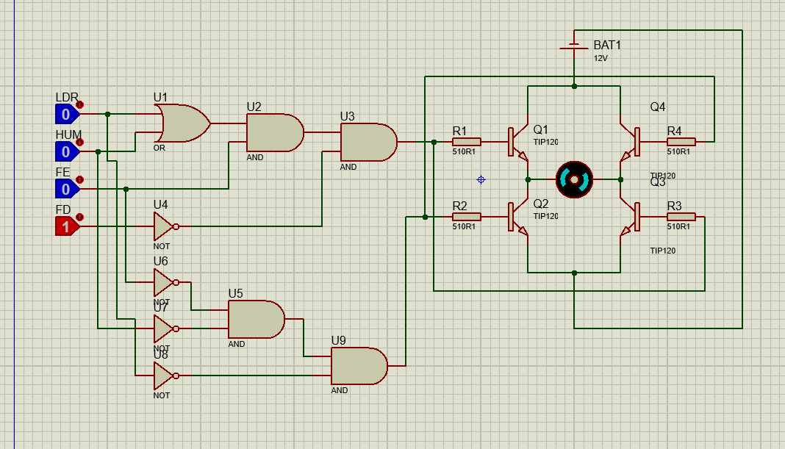

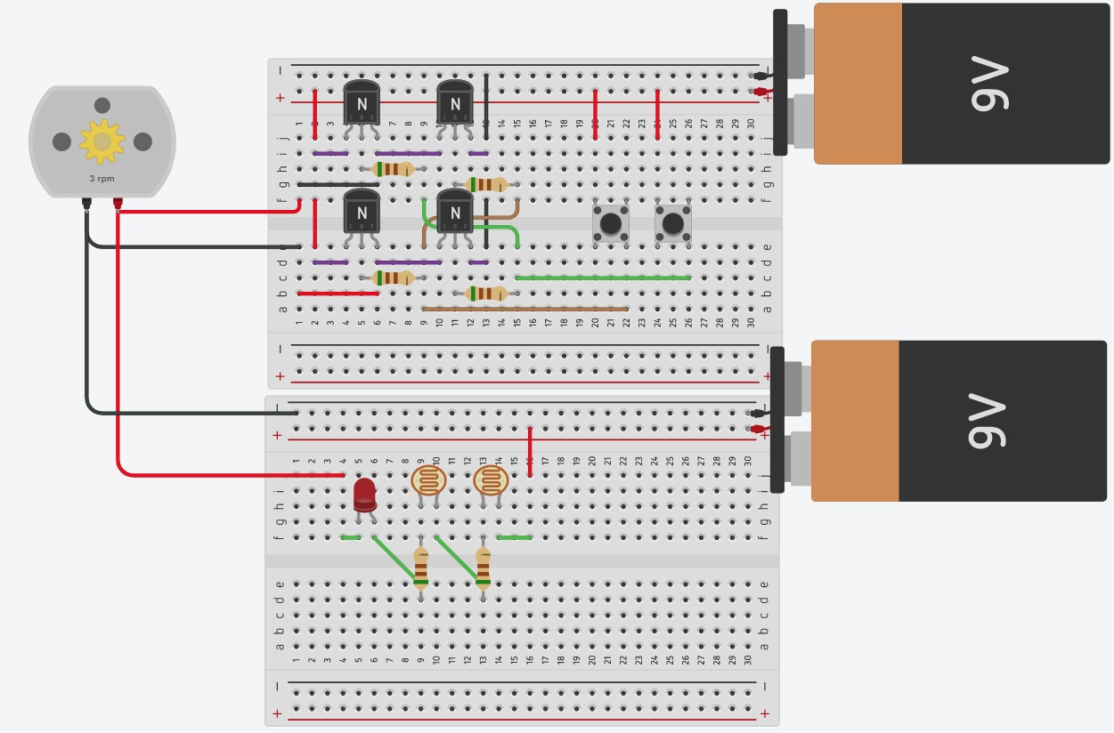

**Verilog**

repeat (16) begin

i = i + 1;

if (i == 0 || i == 1..)

$monitor("%d %b %b %b %b %b %b", $time, ld, u, d , e, A, B);

end

initial begin

i = 0;

end

repeat (16) begin

i = i + 1;

if (i == 0 i == 1 i ==4 i==6i==8i==10i==12||i=14)

$monitor("%d %b %b %b %b %b %b", $time, ld, u, d , e, A, B);

initial begin

i = 0;

end

repeat (16) begin

i = i + 1;

if (i == 0 i == 1 i ==4 i==6i==8i==10i==12||i=14) begin

$monitor("%d %b %b %b %b %b %b", $time, ld, u, d , e, A, B);

end

end

initial begin

i = 0;

end

repeat (16) begin

i = i + 1;

if (i == 0 | i == 1 | i ==4 | i==6 | i==8 | i ==10 | i==12 |i=14) begin

$monitor("%d %b %b %b %b %b %b", $time, ld, u, d , e, A, B);

end

end

initial begin

for (i = 0; i < 16; i=i+1) begin

if (i == 0 | i == 1 | i ==4 | i==6 | i==8 | i ==10 | i==12 |i=14) begin

$monitor("%d %b %b %b %b %b %b", $time, ld, u, d , e, A, B);

end

end

end